Fresh Choice Diary Website Project Copies

Retail Business Logo
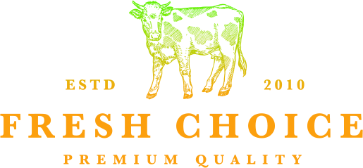

Home Page

Moto: Premium Quality Diary

Premium Quality Dairy

Welcome to Fresh Choice Dairy
Fresh Choice Dairy is a local family-owned dairy business. We provide fresh dairy products made using full-cream, hormone-free milk.
Our products are supplied to customers throughout the Border Region of the Eastern Cape.

Our Products
We offer a range of fresh dairy products including fresh milk, traditional maas, cream and butter.

Why Fresh Choice?
Fresh Choice focuses on providing locally sourced dairy products while maintaining its local and family-owned identity.

Get in Touch
Have a question about our products? Visit our enquiry page to get in touch with us.

About us
Fresh choice is a local, family owned dairy, established in 2010 and now operationg
from the Cave Rock costal area of East London.

Our History...
Fresh Choice was established in 2010 by a Aiden Sansom.
It started as a roadside farm stall supplying the rural communities of Chalumna and Good Hope.
The 'Containers', as the roadside farm stall became known, have become 'somewhat' of a landmark
on the R72 between the two Kayer's Beach roads and are still used today as a distributuion hub
for products sold into the rural communities - either for private consumption, or part of school feeding schemes.

How we operate...
Our milk is sourced from local dairies and distributed throughout the Boarder Region of the Eastern Cape - From Port Alfred to Grahamstown, Bedford, Queenstown to Elliot, Qumbu, Toslo, Mthatha, to the coast, and back to East London. All our products are made with milk that is Full Cream and Hormone free - this gives it a distinctive smooth taste.
Fresh Choice Premium Quality Diary

Our Products

Pasteurised full cream maas is a fermented milk product.
This product sold in the following units:
- 500ml
- 1l
- 2l
- 4l

Traditional Maas

A fermented milk product. During the production process, the milk is thermised.
Thermisation is a heat treatment that is applied to milk to reduce the number of spoileage
bacteria with minimal heat damage to the milk. Once this process is complete, the product
is bottled and the milk allowed to 'naturally' ferment, as traditionally left in a calabash
This product is sold in the following units.
- 2l
- 5l

Full Cream Fresh Milk

Our fresh milk is pasteurised but not homogenised. Fresh Choice
believes that milk should be processed as little as possible, and
consumed in the most natural state possible. Homogenisation,
which is not necessary for any food saftey reason, destroys the
sweet, creamy taste of the fresh milk and alters its molecular
structure.
This product is sold in the following units:
- 2l

Fresh Cream

Fresh cream is pasteurised and sold as such. Our cream can be
used for cooking or baking up delicious treats.
This product is available in the following units:
- 1l
- 500ml
- 250ml

Butter (salted and unsalted)

Fresh Choice's butter is traditional farm butter and is made only
from cream, and where applicable, salt is added. The butter is
deliciously creamy, rich and can be used for cooking, baking, or on
freshly baked bread.
This product is available in the following units:
- 500g tubs

Taste the difference

We believe our dairy products should be processed as little as
possible, and consumed in the most natural state possible.
That's why all our products are made with milk that is Full Cream and
Hormone free - this gives them a distinctive smooth taste.

PREMIUM QUALITY DAIRY

Enquiry

Get in Touch
Have a question about our products? Fill in the form below and send us a message.
Top of Form
Your Name:
Your Email:
Message:

Google Form
You can also send your enquiry using our Google Form.

Email
aiden@fresh-choice.co.za

PHONE NUMBER
043 555 0449

Location
Prince George Circuit, KuGompo City, 5201

Bottom of Form

